**Prerequisite:**

1. Have java installed, to install java run the command: sudo yum install java -y

* Download the rpm repo file and install artifactory. See<https://www.jfrog.com/confluence/display/RTF/Installing+on+Linux+Solaris+or+Mac+OS> for more information.

|  |
| --- |
| *wget*[*https://bintray.com/jfrog/artifactory-rpms/rpm*](https://bintray.com/jfrog/artifactory-rpms/rpm)*-Obintray-jfrog-artifactory-rpms.repo*  *sudo mv bintray-jfrog-artifactory-rpms.repo /etc/yum.repos.d/*  *sudo yum install jfrog-artifactory-oss* |

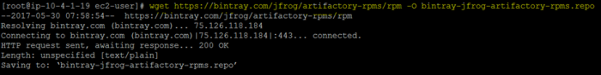

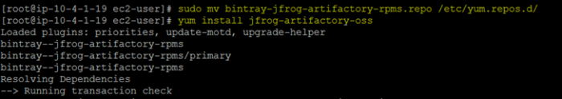

* Create a symbolic link to the Artifactory installation

|  |
| --- |
| *cd /opt/app*  *ln -s /etc/opt/jfrog/artifactory/ /opt/app/artifactory* |

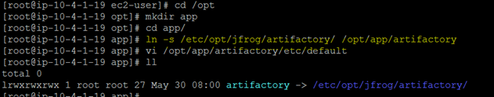

* Start Artifactory.

|  |
| --- |
| *sudo service artifactory start* |

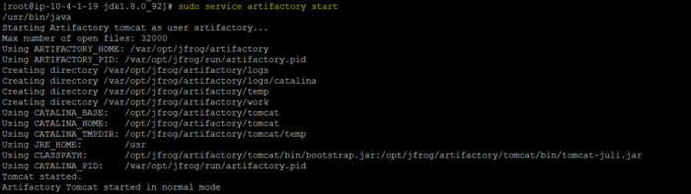

* To access the artifactory open the link :<http://host:8081/artifactory>
* [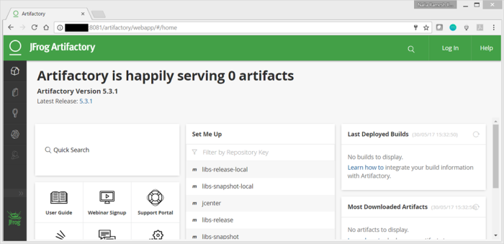](http://host:8081/artifactory)
* When you access the above URL for the first time, it prompts for setting a password. Set a password of your choice.
* And add your choice of remote repositories.
* 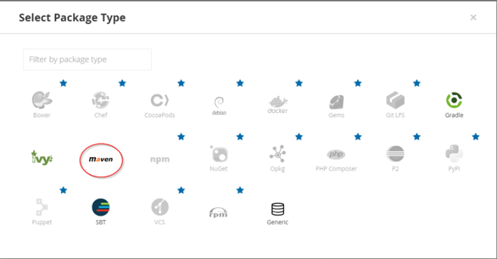

And create default repo.